### Work Smart by Microsoft IT

Successful meetings with Skype for Business

Traditional meetings can be a challenge when people are spread out over long distances. Communication technology can overcome this physical boundary by allowing people to attend from any location with Internet or phone access. In addition, by understanding the best practices for conducting meetings and productively using Skype for Business, you can make your meetings more efficient and effective.

Topics in this guide include:

Getting started

Best practices for Skype for Business meetings

Scheduling and joining a meeting

Sharing during meetings

Recording a meeting

For more information

Getting started

Skype for Business helps you be more efficient by:

* Streamlining multiple communication tools into one.
* Allowing simple meeting organization and execution right from Outlook.
* Reducing coordination of physical meeting spaces, audio conference numbers, and internet communication technologies.
* Facilitating back-to-back meetings while remaining at your desk.

To get started with Skype for Business, you will need:

* Skype for Business software.
* An audio device and webcam (optional).

Checking your audio and video devices

Before you use Skype for Business to make or receive calls, check your settings to make sure your audio and video devices are configured to function the way you expect.

1. Click the **Options** button  on the upper-right side of the Skype for Business main window.
2. To check your audio settings, click **Audio Device** in the **Skype for Business – Options** dialog box. Use the testing buttons on this page to make sure your speaker, microphone, and ringer are all working, and that your call quality is acceptable.
3. To check your video settings, click **Video Device**. Verify that your camera is working properly and adjust camera settings as needed.

NOTE: Do not use your webcam as the default audio device.

Setting your meeting space options in Microsoft Outlook

It’s a good idea to set up your meeting space options from the start. There are two Skype for Business meeting space options that you can set through Outlook:

* The **A new meeting space (I control permissions)** option creates a brand new Skype for Business meeting with a unique ID. You can customize permissions (such as who gets to be a presenter), mute people, or prevent people from sharing video.

TIP: Choose this option to avoid the problem of having meeting participants in a current meeting mix with participants joining at the end of that meeting.

* The **My dedicated meeting space (less secure)** option creates all meetings in the same space with the same entry info. Anyone from Microsoft can get into the meeting as a presenter.

TIP: Choose this option to always use the same Skype for Business meeting ID and permissions. Content, such as a Microsoft PowerPoint presentation, remains in the meeting until you delete it. This is a good option for informal and regular meetings with coworkers.

To set Skype for Business meeting space options:

1. In Outlook, open the **Calendar**, and then click **New Skype Meeting**.  
     
   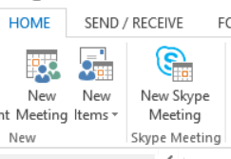
2. Click **Meeting Options**.



1. In the **Skype Meeting Options** dialog box, select one of the meeting space options.   
     
   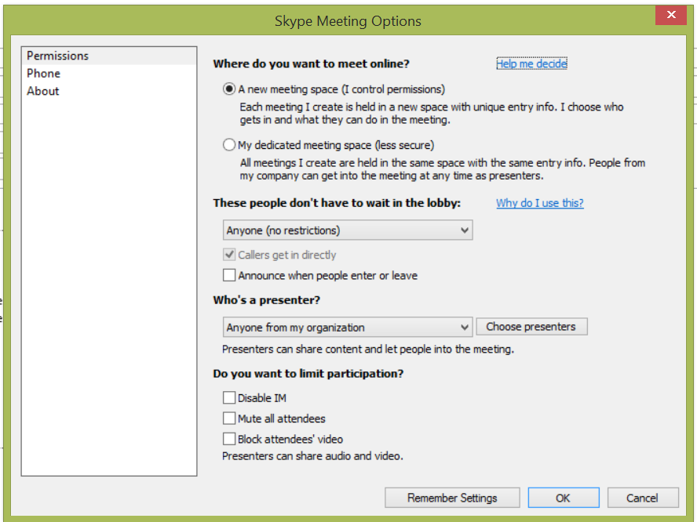
2. Click **Remember Settings**.

Best practices for Skype for Business meetings

Attendees

* Use an audio device to avoid echoes or other audio issues.
* To prevent audio feedback, if other attendees are sitting in the same room, use only one computer to log on to the meeting.
* Mute your audio unless you are speaking.
* Do not take a call from your cell phone, particularly while driving. Road noise diminishes the meeting’s audio quality and driving while distracted is dangerous.
* Use a wired Ethernet connection whenever possible.

Presenters

* Set up and test your audio devices 15-20 minutes before the start of your meeting (when possible).
* Provide a clear and complete invitation, including a meeting agenda.
* Join your meeting early to prepare your content. Upload slides or documents to be shared, and start applications you want others to view during sharing.
* Set your screen display to 1024 x 768 pixels for the best viewing experience (800 x 600 portrait for tablet PCs).
* Mute participants who cause a poor audio experience.
* Enlist the help of an assistant for larger meetings.

Scheduling and joining a meeting

Skype for Business is integrated with Outlook to allow meeting requests to be sent and received via email between organizers and attendees. The Outlook add-in for Skype for Business is installed automatically when Office is installed.

Skype for Business supports online meetings and calls (video and audio). One meeting request is used for both purposes.

Scheduling a Skype for Business meeting in Outlook

You can use Outlook or Outlook Web App to schedule a Skype meeting--the same way you schedule meetings normally but with one or two extra clicks. If your account is configured for dial-in conferencing, the Skype meeting request will automatically include call-in information (phone number and conference ID).

1. Open your Outlook **Calendar**, click the **Home** tab, and then click **New Skype Meeting**.



1. In the **To…** box, enter the email addresses for the people you want to invite.
2. Type a subject, and then select a start and end time.

Set up the meeting:

1. Type the agenda in the meeting area but be careful not to change any of the Skype for Business meeting information.
2. Click the **Scheduling Assistant** (optional) on the **Meeting** ribbon to check schedules for the people you are inviting. Click a time slot to select a different time.



TIP:It is both common courtesy and a best practice to check the calendar to determine whether any of your invitees have a schedule conflict. When there is a conflict, be proactive and send a separate note to them to see if they can attend the meeting. Assume all calendars are up to date.

1. Double-check the information, and then click **Send**.

TIPS:

* If you have both in-person and online attendees, you might want to run your Skype for Business meeting in a conference room. From the Meeting ribbon, click Room Finder in the Scheduling Assistant to find and add a conference room of your choice. Or book the room separately, and then add the room information in the Location box.   
    
   Outlook, the Room Finder button
* If your meeting is with people outside your company, or you’re scheduling a large event, change the meeting options before sending the meeting request to better fit your meeting requirements. For more information, see “Getting started” earlier in this document.

Joining a scheduled Skype for Business meeting

Most of the time, joining a Skype for Business meeting is as simple as clicking the meeting link. And you can join from anywhere, such as an airport, a coffee shop, your hotel, or your mobile device when you’re on the road, whether you’re connected to your corporate network or not.

Scenario 1: Joining a Skype for Business meeting from Outlook

To join a Skype for Business meeting from an Outlook meeting request, click **Join Skype Meeting**.

-OR-

From the meeting reminder, click **Join Online**.

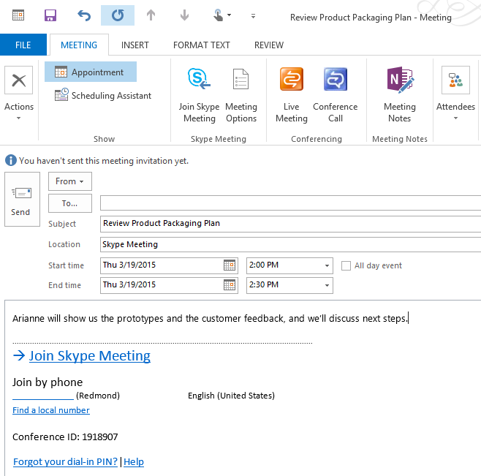



TIP: You can also join a meeting by right-clicking the meeting in the Calendar, and then clicking Join Skype Meeting.

Scenario 2: Joining a meeting from Skype for Business

From the Skype for Business main window, you can join a Skype for Business meeting right from the **Meetings** tab, if the meeting was set up by an organizer inside your company.

1. To do this, click the **Meetings** tab in the Skype for Business main window.
2. Right-click a Skype for Business meeting to join, and then click **Join**.

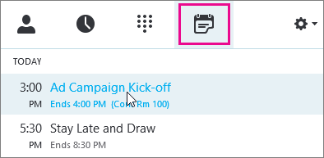

Scenario 3: Joining a Skype for Business meeting using a non-work computer

Use Skype for Business Web App to join a Skype for Business meeting from your browser if you do not have Skype for Business installed.

1. Connect an audio device to your computer. If you do not have an audio device, you can dial in with a phone to connect to the audio portion of the meeting.
2. Click the **Join Skype Meeting** link in the Outlook invitation.
3. Type your name in the text box, and make sure that the option to install the **Skype for Web app plug-in** is selected.
4. Click **Join Meeting**.
5. When prompted to run or save the plug-in file, click **Run**.

Scenario 4: Joining a Skype for Business meeting using a mobile phone

1. Dial the conference dial-in number listed in the meeting invitation.   
     
   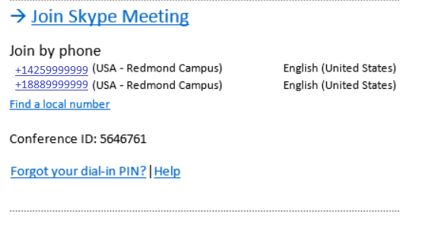
2. When prompted, enter the Conference ID.

NOTES:

* Upon joining a meeting, each attendee is muted by default.
* If you are joining the meeting from your work computer or Enterprise Voice-enabled work phone, you don’t have to enter a PIN or passcode. If you are joining with a mobile phone that isn’t configured with your account, you may be asked for a PIN and work number/extension. You can find this information in the invitation link.

Starting an unplanned meeting

Start an impromptu meeting to discuss a subject that needs immediate attention.

1. Select your Skype for Business contacts by holding down the **CTRL** key as you click each name in your Contact list.
2. Right-click any of the selected names, and then click **Start a Conference Call** or if you prefer video **Start a Video Call**.



TIP:To add more contacts to the call, just drag them from the Contacts list to the group conversation window.

Sharing during meetings

You can share any of the following in a Skype for Business meeting:

* **Desktop**. Let other participants view your desktop as you view it.
* **Program**. Let other participants view specific programs running on your computer.
* **PowerPoint**. Share a PowerPoint presentation from your computer.
* **Whiteboard**. Use the whiteboard tool to illustrate or to brainstorm with other participants.
* **Poll**. Need quick feedback? Customize a poll and take the pulse from the group.
* **Q&A**. Let people post questions for you or other presenters to answer.
* **Add Attachments**. Share important files and documents with participants for easy download.

IMPORTANT: Use desktop sharing rather than program sharing whenever possible. Desktop sharing uses significantly fewer networking resources than program sharing.

Sharing during a Skype for Business meeting

To present a program in a Skype for Business meeting, it must be running and visible on your Windows taskbar. If you don’t see the program you want to share, you can open it and then just present your desktop. Here's how:

1. At the bottom of the meeting window, click the **Present** icon.
2. Select **Present Desktop** to share the content on your desktop.

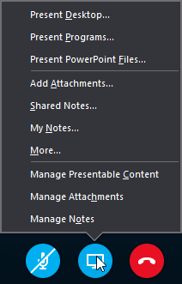

1. In the pop-up window, select the monitor you would like to share and then click **Present** (for example, click **Primary Monitor** or **Monitor 2**).

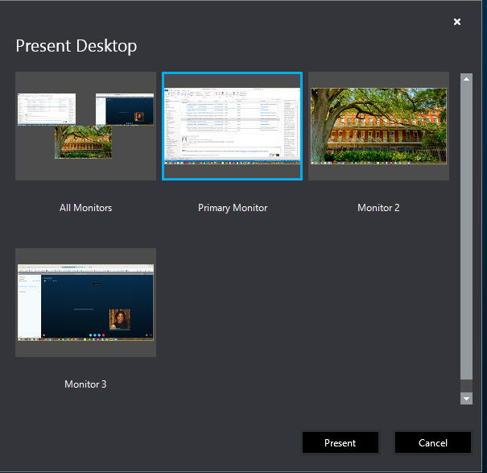

1. If desired, use the sharing toolbar at the top of the screen to give control of your desktop or programs to another participant. Meeting participants can also request control from the sharing toolbar.   
     
   
2. When you have finished sharing, click **Stop Presenting** on the sharing toolbar.



TIPS:

* For best results, when sharing content, use a wired network connection when possible.
* After you create or upload content for sharing, Skype for Business adds it to the Presentable Content list. As you share more content, you can use this list to indicate what content you want to share at any time by tapping or clicking the button and selecting from the options that appear.
* Large PowerPoint presentations can take up to five minutes to load in the sharing window. To save time, join the meeting early and load the file you to share.
* If you experience poor call quality while using your non domain joined computer, use the Provide Feedback  link at the top right of your window to share your experience.

## Sharing live video

If your account is enabled for video calls, you can make face-to-face video calls with your contacts. All you need is a camera and your computer’s speakers and microphone. You can also use a headset if your computer doesn’t have a built-in audio device.

Starting a video call

1. Start Skype for Business, and either find a contact in your Contacts list or type a name in the search box to find the person you’re looking for. (See [Add a contact in Skype for Business](https://support.office.com/en-us/article/Add-a-contact-in-Skype-for-Business-89338023-2adf-4f5c-90b6-f8b6f72fadd1) for details about searching for someone in your organization and also searching for someone with a Skype account.)
2. Hover over the contact’s picture, and then click the **Video** icon.

Quick Video Chat button

A toast alert pops up on your contact’s screen, which they can use to accept or ignore your request.

1. If the video call is accepted, the conversation window expands to display the video. Use the views and controls, such as mute/unmute, as needed.
2. At any time, you can do any of the following:

* To end the call, close the window, or click the hang up button.

Hang Up button

* To stop showing your video, point to the **Video** icon, and then click **End Video**. The audio will continue.
* You can also add video to an existing instant messaging (IM) conversation. Simply click the **Video** icon in the window to start your video.

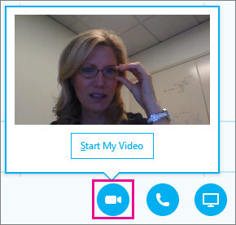

Recording a Skype for Business meeting

When you record a Skype for Business meeting, you capture audio, video, instant messaging, application sharing, PowerPoint presentations, whiteboard, and polling. Skype for Business saves the recording in MP4 format. Only meeting presenters can record a meeting.

IMPORTANT NOTE:Before you begin, inform all attendees that you are recording the meeting.

Creating a recording

1. In the meeting window, click the **Options** button, and then click **Start Recording**.   
     
   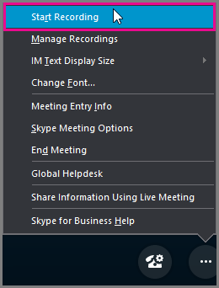

TIP: If the recording option is dimmed, your audio might not be connected. Click the mic icon to connect audio, then try again.

1. Use the controls at the bottom of the meeting to pause, resume, or stop the recording.



1. To see who else is recording, point to the red recording button.
2. When you’re done, click **Stop Recording**.

All recordings have stopped message

1. Skype for Business automatically saves the recording in MP4 format that plays in Windows Media Player. You can exit the meeting while the recording is being processed.

Playing back a recorded meeting

When your recording has been processed, you can access it to play or send to others. Skype for Business displays a message when the recording is ready. You can click the alert to open **Recording Manager**, or if you miss that, click **Tools** on the Skype for Business main window, then click **Recording Manager**. In the **Recording Manager** window:

1. Click your recording to highlight it, and then click **Play** on the right side of the Skype for Business main window.
2. You can also rename or delete your recording here.
3. To share your recording with others, click **Browse** to locate it, then copy the file to post on a shared location, such as your OneDrive for Business or a SharePoint Online site.
4. If you cannot post the recording, check to make sure you have enough space on the page.  
     
   TIP: Recordings are saved in the Videos/Skype for Business Recordings folder on your computer.

For more information

Discover Skype for Business

<https://support.office.com/en-us/article/Discover-Skype-for-Business-8a3491a3-c095-4718-80cf-cbbe4afe4eba?ui=en-US&rs=en-US&ad=US>

Microsoft IT Showcase

http://microsoft.com/ITShowcase

This guide is for informational purposes only. MICROSOFT MAKES NO WARRANTIES, EXPRESS, IMPLIED, OR STATUTORY, AS TO THE INFORMATION IN THIS DOCUMENT. © 2015 Microsoft Corporation. All rights reserved.